# JavaScript for MPO

To take advantage of all the MPO capabilities it is important to understand and have a grasp of the main JavaScript concepts.

For that purpose, it’s advisable to do training on this technology to improve and accelerate the related knowledge. After some research, we identified a basic course on JavaScript, which can be accessed on Udemy, following the steps described below.

## 1 – Access Udemy website

Link: <https://www.udemy.com/>

## 2 – Login with organization

1. 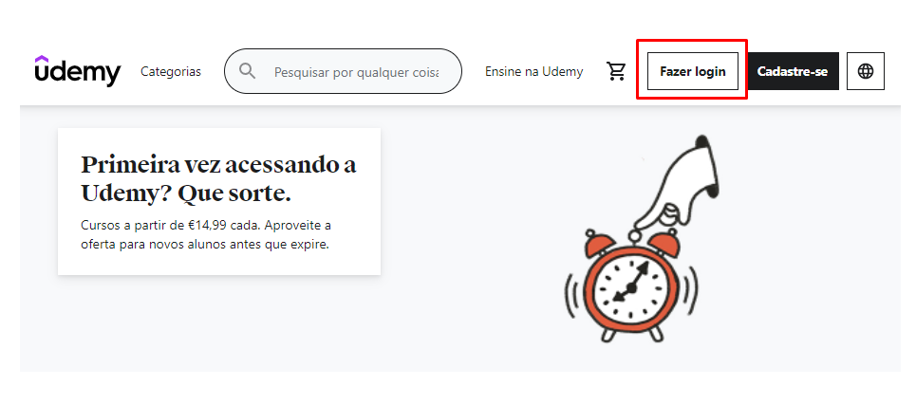
2. 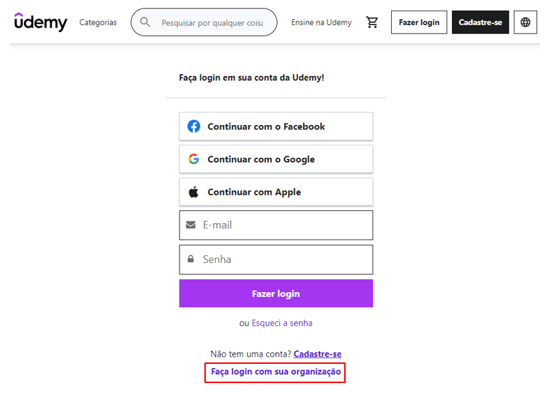

## 3 – Search “JavaScript Basics for Beginners” course

Weblink: <https://deloittedevelopment.udemy.com/course/javascript-basics-for-beginners/>

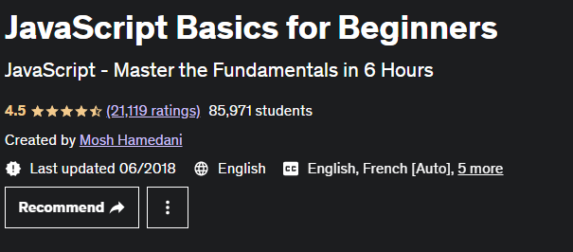

## 4 – Enroll the course

